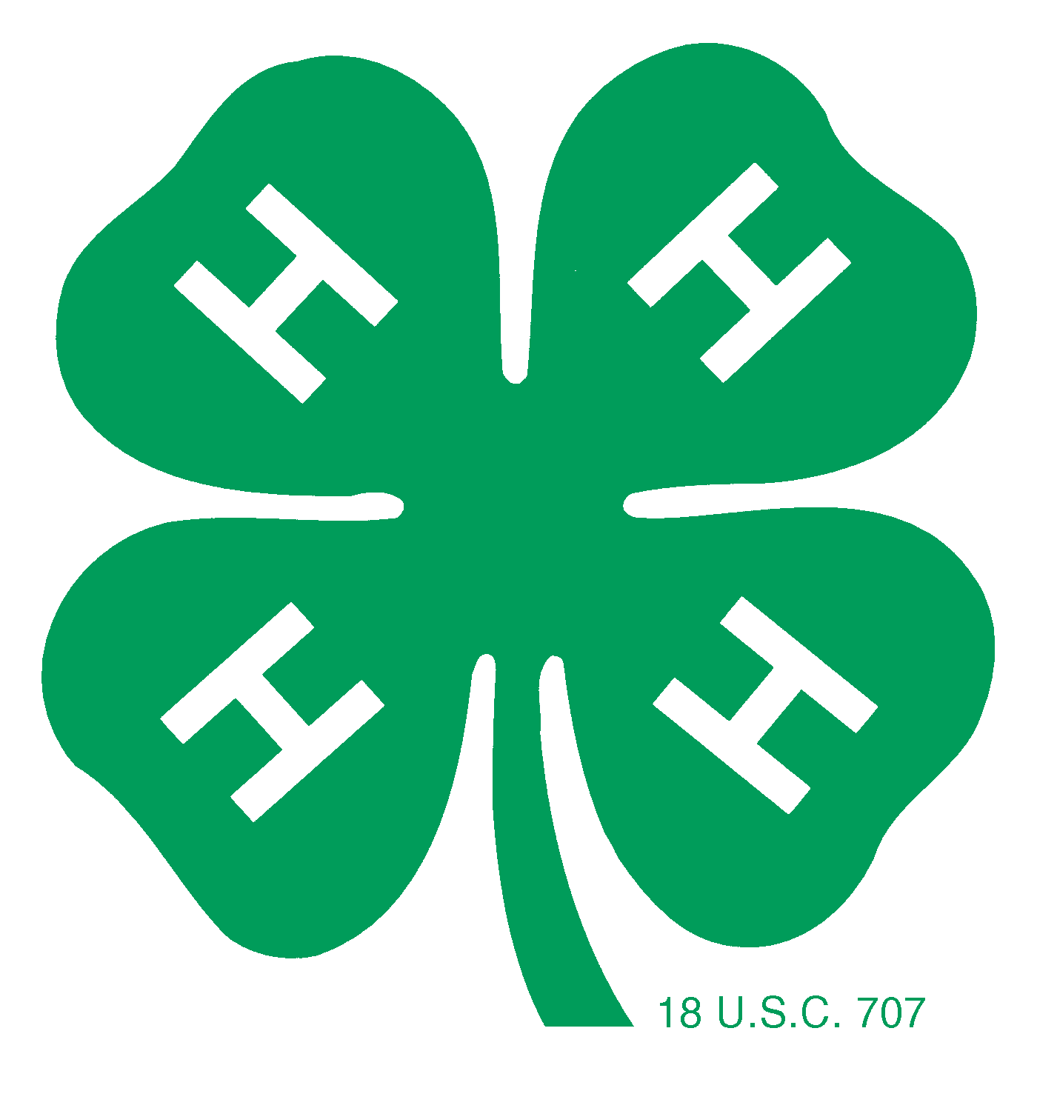
My 4-H Career Record Book

Name: ______________________________________________

Club(s): _____________________________________________

___________________________________________________

___________________________________________________

I became a 4-H member on ______________________________

Keep this book in a safe place and add to it each year.
You’ll have a wonderful record of your 4-H career AND keeping records in this book will make application for awards and scholarships easy!

© adapted from Hocking County 4-H/October2004

OSU Extension
Fairfield County
4-H Youth Development Program

Hannah Kohler
OSU Extension Educator
4-H Youth Development

Sue Suttles
Program Assistant
4-H Youth Development

Ellen Shaw
Office Associate

831 College Avenue, Suite D
Lancaster, OH 43130
740-653-5419 - phone
740-687-7010 - fax
kohler.61@osu.edu

Edited by: Sue Suttles, Program Assistant, 4-H Youth Development, Fairfield County
Hannah Kohler, Extension Educator, 4-H Youth Development, Fairfield County

Material used with permission from the following original authors:
Barbara Carder, OSU Extension Educator, 4-H Youth Development, Hocking County
Sheila Meyer, Program Assistant, 4-H Youth Development, Hocking County
Sue Sharb, Office Associate, Hocking County
My 1st year in 4-H was _______

Club: _______________________________________________________________________

Advisors: ____________________________________________________________________

Projects completed: ____________________________________________________________

Project summary (grade, placing at project review, placing at fair, etc.)

____________________________________________________________________________

____________________________________________________________________________

What I learned this year: ________________________________________________________

____________________________________________________________________________

Offices held this year: __________________________________________________________

Community Service projects I worked on (both related to 4-H and others):

__________________________________________________________________________

__________________________________________________________________________

Committees I served on: _______________________________________________________

__________________________________________________________________________

Contests I participated in: ______________________________________________________

__________________________________________________________________________

Awards I received during this year: _______________________________________________

__________________________________________________________________________

Other accomplishments (participated in livestock skillathon and/or project reviews, attended camp, served as camp counselor, honor member, honor club, scholarships received, leadership given):

__________________________________________________________________________
__________________________________________________________________________
__________________________________________________________________________
__________________________________________________________________________
__________________________________________________________________________
__________________________________________________________________________
My 2nd year in 4-H was _______
Club: _______________________________________________________________________

Advisors: ____________________________________________________________________

Projects completed: ____________________________________________________________

Project summary (grade, placing at project review, placing at fair, etc.)

____________________________________________________________________________

____________________________________________________________________________

What I learned this year: ________________________________________________________

____________________________________________________________________________

Offices held this year: __________________________________________________________

Community Service projects I worked on (both related to 4-H and others):

__________________________________________________________________________

__________________________________________________________________________

Committees I served on: _______________________________________________________

__________________________________________________________________________

Contests I participated in: ______________________________________________________

__________________________________________________________________________

Awards I received during this year: _______________________________________________

__________________________________________________________________________

Other accomplishments (participated in livestock skillathon and/or project reviews, attended camp, served as camp counselor, honor member, honor club, scholarships received, leadership given):

__________________________________________________________________________
__________________________________________________________________________
__________________________________________________________________________
__________________________________________________________________________
__________________________________________________________________________
__________________________________________________________________________
My 3rd year in 4-H was _______

Club: _______________________________________________________________________

Advisors: ____________________________________________________________________

Projects completed: ____________________________________________________________

Project summary (grade, placing at project review, placing at fair, etc.)

____________________________________________________________________________

____________________________________________________________________________

What I learned this year: ________________________________________________________

____________________________________________________________________________

Offices held this year: __________________________________________________________

Community Service projects I worked on (both related to 4-H and others):

__________________________________________________________________________

__________________________________________________________________________

Committees I served on: _______________________________________________________

__________________________________________________________________________

Contests I participated in: ______________________________________________________

__________________________________________________________________________

Awards I received during this year: _______________________________________________

__________________________________________________________________________

Other accomplishments (participated in livestock skillathon and/or project reviews, attended camp, served as camp counselor, honor member, honor club, scholarships received, leadership given):

__________________________________________________________________________
__________________________________________________________________________
__________________________________________________________________________
__________________________________________________________________________
__________________________________________________________________________
__________________________________________________________________________
My 4th year in 4-H was _______

Club: _______________________________________________________________________

Advisors: ____________________________________________________________________

Projects completed: ____________________________________________________________

Project summary (grade, placing at project review, placing at fair, etc.)

____________________________________________________________________________

____________________________________________________________________________

What I learned this year: ________________________________________________________

____________________________________________________________________________

Offices held this year: __________________________________________________________

Community Service projects I worked on (both related to 4-H and others):

__________________________________________________________________________

__________________________________________________________________________

Committees I served on: _______________________________________________________

__________________________________________________________________________

Contests I participated in: ______________________________________________________

__________________________________________________________________________

Awards I received during this year: _______________________________________________

__________________________________________________________________________

Other accomplishments (participated in livestock skillathon and/or project reviews, attended camp, served as camp counselor, honor member, honor club, scholarships received, leadership given):

__________________________________________________________________________
__________________________________________________________________________
__________________________________________________________________________
__________________________________________________________________________
__________________________________________________________________________
__________________________________________________________________________
My 5th year in 4-H was _______

Club: _______________________________________________________________________

Advisors: ____________________________________________________________________

Projects completed: ____________________________________________________________

Project summary (grade, placing at project review, placing at fair, etc.)

____________________________________________________________________________

____________________________________________________________________________

What I learned this year: ________________________________________________________

____________________________________________________________________________

Offices held this year: __________________________________________________________

Community Service projects I worked on (both related to 4-H and others):

__________________________________________________________________________

__________________________________________________________________________

Committees I served on: _______________________________________________________

__________________________________________________________________________

Contests I participated in: ______________________________________________________

__________________________________________________________________________

Awards I received during this year: _______________________________________________

__________________________________________________________________________

Other accomplishments (participated in livestock skillathon and/or project reviews, attended camp, served as camp counselor, honor member, honor club, scholarships received, leadership given):

__________________________________________________________________________
__________________________________________________________________________
__________________________________________________________________________
__________________________________________________________________________
__________________________________________________________________________
__________________________________________________________________________
My 6th year in 4-H was _______

Club: _______________________________________________________________________

Advisors: ____________________________________________________________________

Projects completed: ____________________________________________________________

Project summary (grade, placing at project review, placing at fair, etc.)

____________________________________________________________________________

____________________________________________________________________________

What I learned this year: ________________________________________________________

____________________________________________________________________________

Offices held this year: __________________________________________________________

Community Service projects I worked on (both related to 4-H and others):

__________________________________________________________________________

__________________________________________________________________________

Committees I served on: _______________________________________________________

__________________________________________________________________________

Contests I participated in: ______________________________________________________

__________________________________________________________________________

Awards I received during this year: _______________________________________________

__________________________________________________________________________

Other accomplishments (participated in livestock skillathon and/or project reviews, attended camp, served as camp counselor, honor member, honor club, scholarships received, leadership given):

__________________________________________________________________________
__________________________________________________________________________
__________________________________________________________________________
__________________________________________________________________________
__________________________________________________________________________
__________________________________________________________________________
My 7th year in 4-H was _______

Club: _______________________________________________________________________

Advisors: ____________________________________________________________________

Projects completed: ____________________________________________________________

Project summary (grade, placing at project review, placing at fair, etc.)

____________________________________________________________________________

____________________________________________________________________________

What I learned this year: ________________________________________________________

____________________________________________________________________________

Offices held this year: __________________________________________________________

Community Service projects I worked on (both related to 4-H and others):

__________________________________________________________________________

__________________________________________________________________________

Committees I served on: _______________________________________________________

__________________________________________________________________________

Contests I participated in: ______________________________________________________

__________________________________________________________________________

Awards I received during this year: _______________________________________________

__________________________________________________________________________

Other accomplishments (participated in livestock skillathon and/or project reviews, attended camp, served as camp counselor, honor member, honor club, scholarships received, leadership given):

__________________________________________________________________________
__________________________________________________________________________
__________________________________________________________________________
__________________________________________________________________________
__________________________________________________________________________
__________________________________________________________________________
My 8th year in 4-H was _______

Club: _______________________________________________________________________

Advisors: ____________________________________________________________________

Projects completed: ____________________________________________________________

Project summary (grade, placing at project review, placing at fair, etc.)

____________________________________________________________________________

____________________________________________________________________________

What I learned this year: ________________________________________________________

____________________________________________________________________________

Offices held this year: __________________________________________________________

Community Service projects I worked on (both related to 4-H and others):

__________________________________________________________________________

__________________________________________________________________________

Committees I served on: _______________________________________________________

__________________________________________________________________________

Contests I participated in: ______________________________________________________

__________________________________________________________________________

Awards I received during this year: _______________________________________________

__________________________________________________________________________

Other accomplishments (participated in livestock skillathon and/or project reviews, attended camp, served as camp counselor, honor member, honor club, scholarships received, leadership given):

__________________________________________________________________________
__________________________________________________________________________
__________________________________________________________________________
__________________________________________________________________________
__________________________________________________________________________
__________________________________________________________________________
My 9th year in 4-H was _______

Club: _______________________________________________________________________

Advisors: ____________________________________________________________________

Projects completed: ____________________________________________________________

Project summary (grade, placing at project review, placing at fair, etc.)

____________________________________________________________________________

____________________________________________________________________________

What I learned this year: ________________________________________________________

____________________________________________________________________________

Offices held this year: __________________________________________________________

Community Service projects I worked on (both related to 4-H and others):

__________________________________________________________________________

__________________________________________________________________________

Committees I served on: _______________________________________________________

__________________________________________________________________________

Contests I participated in: ______________________________________________________

__________________________________________________________________________

Awards I received during this year: _______________________________________________

__________________________________________________________________________

Other accomplishments (participated in livestock skillathon and/or project reviews, attended camp, served as camp counselor, honor member, honor club, scholarships received, leadership given):

__________________________________________________________________________
__________________________________________________________________________
__________________________________________________________________________
__________________________________________________________________________
__________________________________________________________________________
__________________________________________________________________________
My 10th year in 4-H was _______

Club: _______________________________________________________________________

Advisors: ____________________________________________________________________

Projects completed: ____________________________________________________________

Project summary (grade, placing at project review, placing at fair, etc.)

____________________________________________________________________________

____________________________________________________________________________

What I learned this year: ________________________________________________________

____________________________________________________________________________

Offices held this year: __________________________________________________________

Community Service projects I worked on (both related to 4-H and others):

__________________________________________________________________________

__________________________________________________________________________

Committees I served on: _______________________________________________________

__________________________________________________________________________

Contests I participated in: ______________________________________________________

__________________________________________________________________________

Awards I received during this year: _______________________________________________

__________________________________________________________________________

Other accomplishments (participated in livestock skillathon and/or project reviews, attended camp, served as camp counselor, honor member, honor club, scholarships received, leadership given):

__________________________________________________________________________
__________________________________________________________________________
__________________________________________________________________________
__________________________________________________________________________
__________________________________________________________________________
__________________________________________________________________________
My 11th year in 4-H was _______

Club: _______________________________________________________________________

Advisors: ____________________________________________________________________

Projects completed: ____________________________________________________________

Project summary (grade, placing at project review, placing at fair, etc.)

____________________________________________________________________________

____________________________________________________________________________

What I learned this year: ________________________________________________________

____________________________________________________________________________

Offices held this year: __________________________________________________________

Community Service projects I worked on (both related to 4-H and others):

__________________________________________________________________________

__________________________________________________________________________

Committees I served on: _______________________________________________________

__________________________________________________________________________

Contests I participated in: ______________________________________________________

__________________________________________________________________________

Awards I received during this year: _______________________________________________

__________________________________________________________________________

Other accomplishments (participated in livestock skillathon and/or project reviews, attended camp, served as camp counselor, honor member, honor club, scholarships received, leadership given):

__________________________________________________________________________
__________________________________________________________________________
__________________________________________________________________________
__________________________________________________________________________
__________________________________________________________________________
__________________________________________________________________________
My 12th year in 4-H was _______

Club: _______________________________________________________________________

Advisors: ____________________________________________________________________

Projects completed: ____________________________________________________________

Project summary (grade, placing at project review, placing at fair, etc.)

____________________________________________________________________________

____________________________________________________________________________

What I learned this year: ________________________________________________________

____________________________________________________________________________

Offices held this year: __________________________________________________________

Community Service projects I worked on (both related to 4-H and others):

__________________________________________________________________________

__________________________________________________________________________

Committees I served on: _______________________________________________________

__________________________________________________________________________

Contests I participated in: ______________________________________________________

__________________________________________________________________________

Awards I received during this year: _______________________________________________

__________________________________________________________________________

Other accomplishments (participated in livestock skillathon and/or project reviews, attended camp, served as camp counselor, honor member, honor club, scholarships received, leadership given):

__________________________________________________________________________
__________________________________________________________________________
__________________________________________________________________________
__________________________________________________________________________
__________________________________________________________________________
__________________________________________________________________________

